**8515 Jackrabbit Road, Ste R**

**Houston, TX 77095**

**+1 (713) 554-2678**

[**sales@zahroofvalves.com**](mailto:sales@zahroofvalves.com)

**version 1.1**

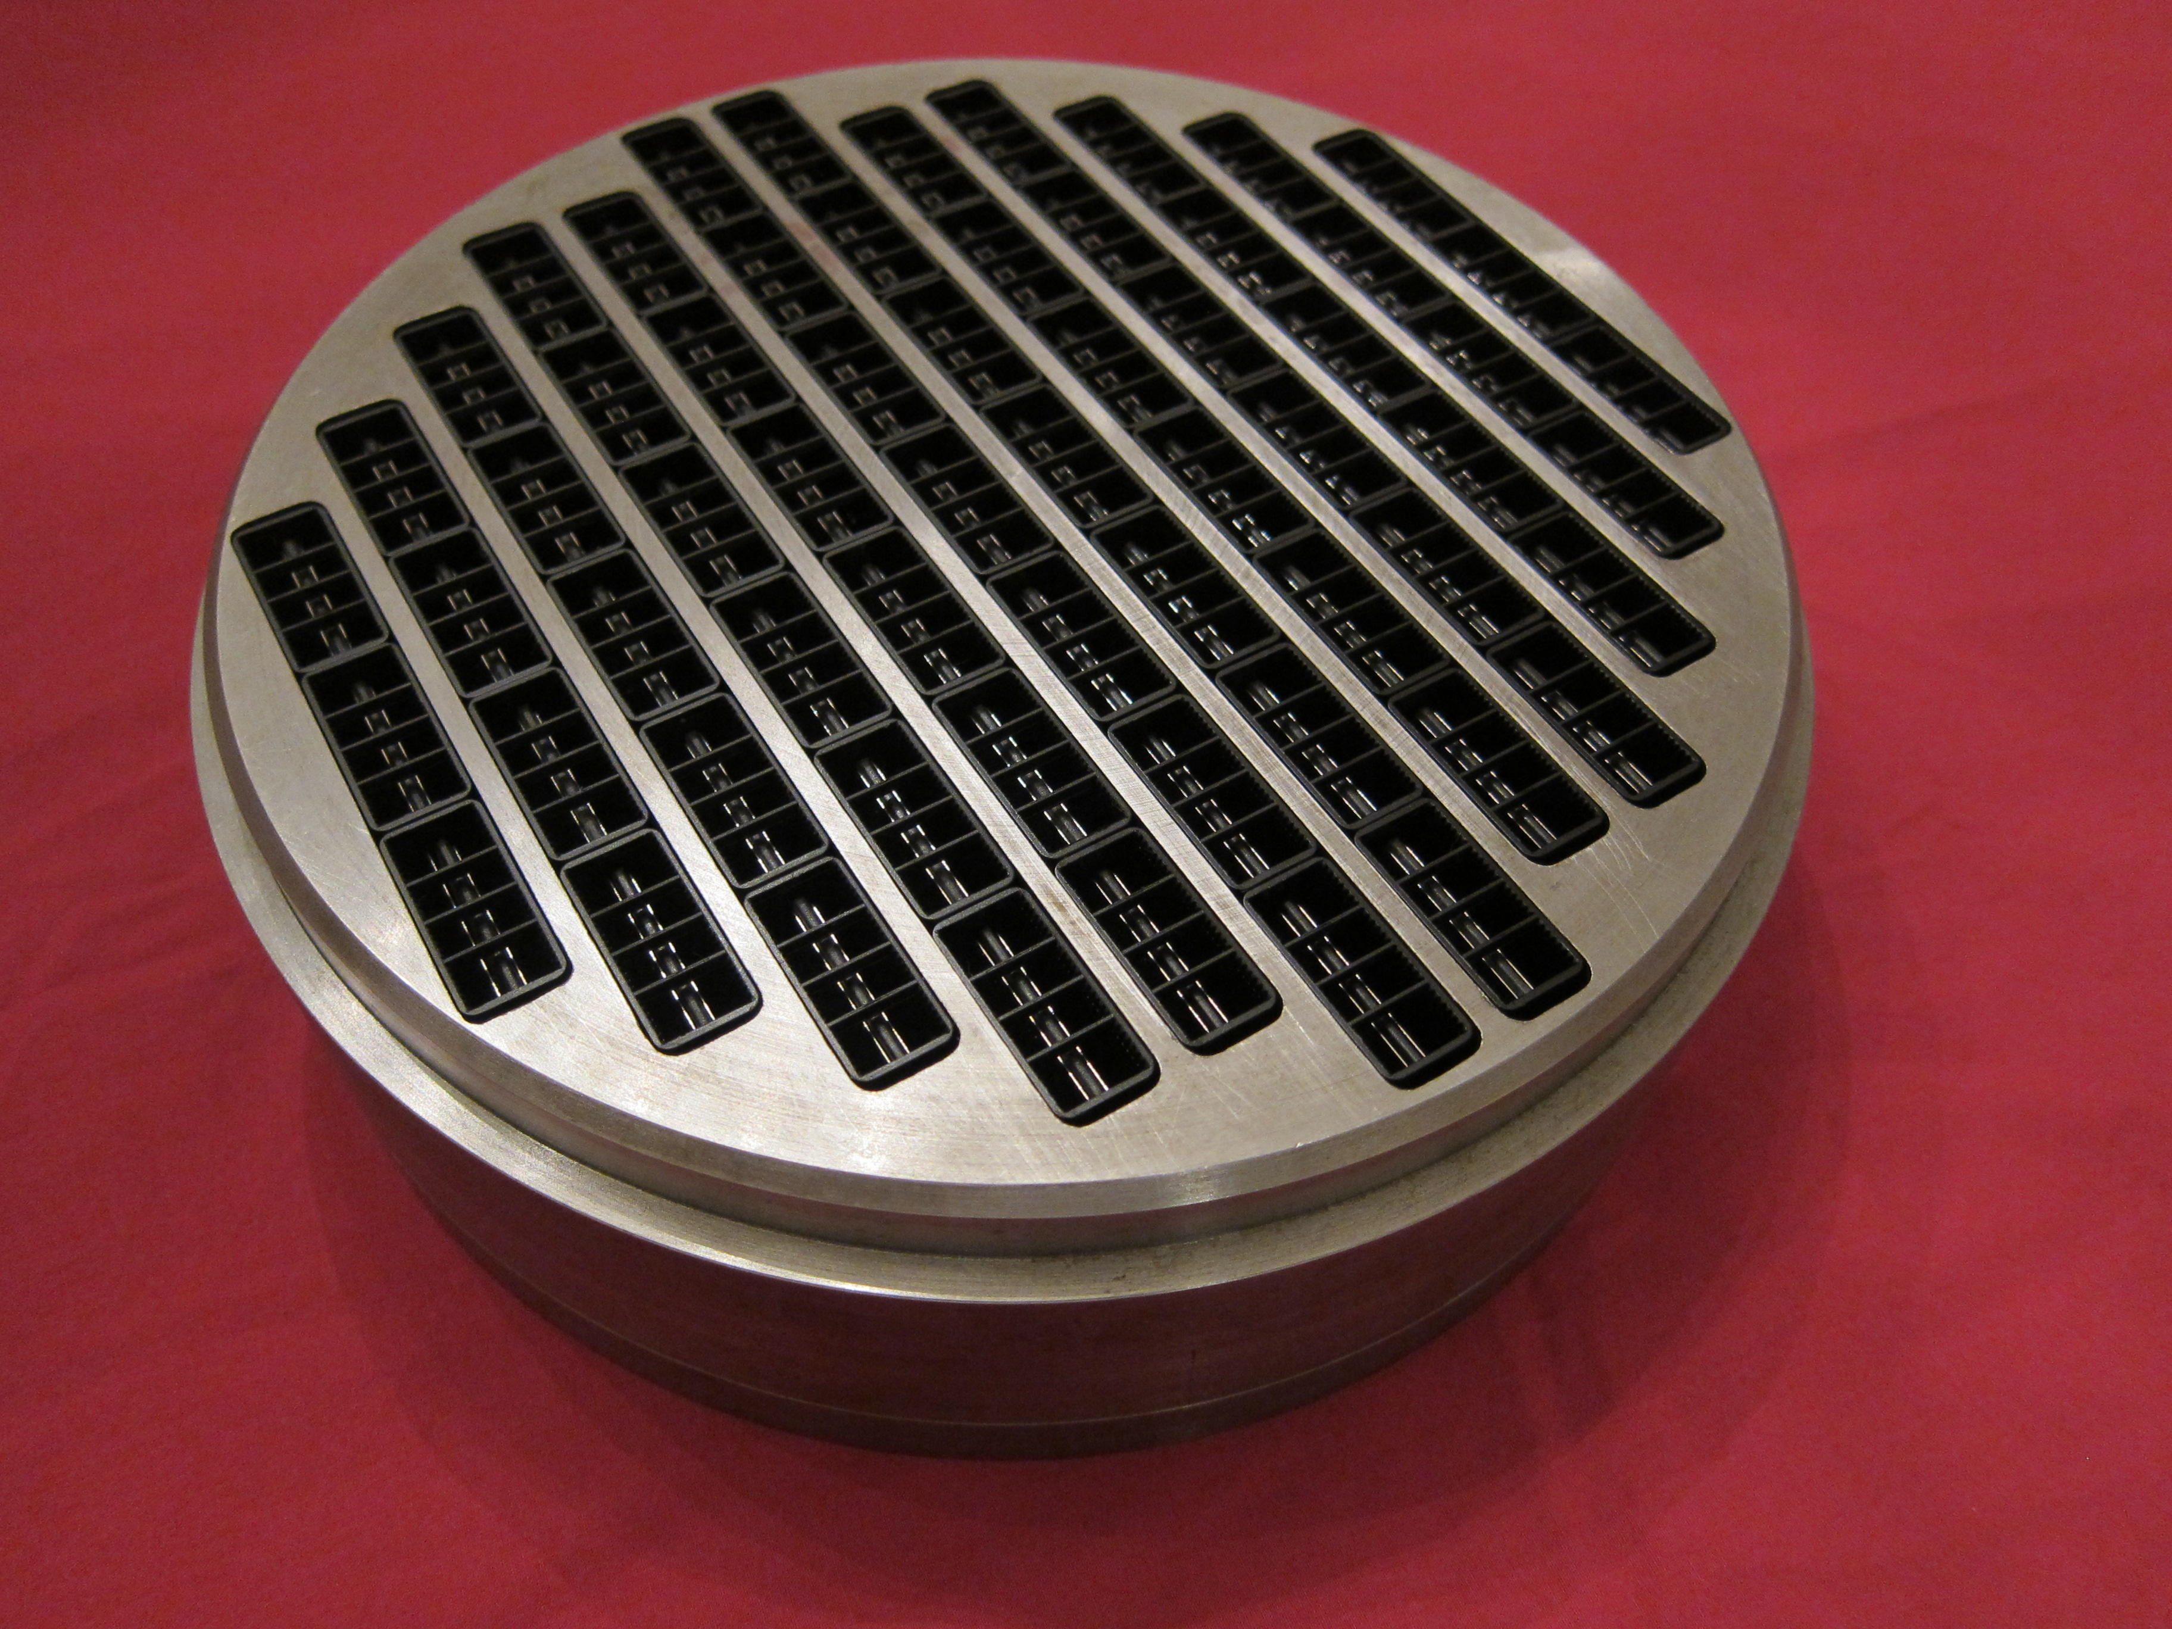

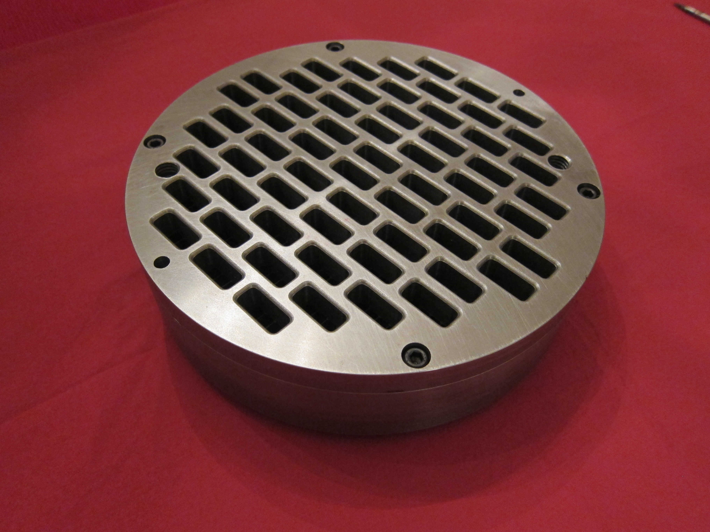

**REQUEST FOR VALVE QUOTATION**



Please be advised that this document will be held and treated as an acting legal electronic document/signature. All information provided must be correct and precise. Customers and/or distributors will be held accountable for the accuracy of the data provided.

;

|  |  |  |  |
| --- | --- | --- | --- |
| **Prepared by:** |  | **Company:** |  |
| **Phone #:** |  | **E-Mail:** |  |

|  |  |  |  |
| --- | --- | --- | --- |
| **Customer Information** | | **Manufacturer Data** | |
| **Customer Name** |  | **Compressor Model** |  |
| **Location Name** |  | **Compressor SN** |  |
| **Address** |  | **Driver Model** |  |
| **City** |  | **Driver SN** |  |
| **State, Zip** |  | **Rated HP** |  |
| **Contact Phone No** |  | **Stroke (in)** |  |
| **Contact Name** |  | **RPM** |  |
| **Contact E-mail** |  | **Conn Rod Length** |  |
| **Atmos. Press (psia)** |  |  |  |

**Objective(s): Enter objectives in the order of priority.**

|  |  |  |  |
| --- | --- | --- | --- |
| **1** | **Improve Reliability/Life** | **2** | **Reduce service/inventory costs** |
| **3** | **Improve Efficiency** | **4** | **Increase throughput** |

**Objects and tables followed by “*” are optional.**

|  |  |  |  |  |  |  |
| --- | --- | --- | --- | --- | --- | --- |
| **Operating Data** | **Stage 1** | **Stage 2** | **Stage 3** | **Stage 4** | **Stage 5** | **Stage 6** |
| Throw # |  |  |  |  |  |  |
| 1Gas Description |  |  |  |  |  |  |
| Suction Pres (PSIG) |  |  |  |  |  |  |
| Suction Temp (°F) |  |  |  |  |  |  |
| Discharge Pres (PSIG) |  |  |  |  |  |  |
| Discharge Temp (°F)* |  |  |  |  |  |  |
| Flow (MMSCFD)* |  |  |  |  |  |  |
| **Compressor Cylinder Data** |  |  |  |  |  |  |
| Cylinder Model |  |  |  |  |  |  |
| Cylinder SN |  |  |  |  |  |  |
| Cylinder Bore Dia (in) |  |  |  |  |  |  |
| HE Fixed Clearance (%) |  |  |  |  |  |  |
| CE Fixed Clearance (%) |  |  |  |  |  |  |
| Piston Rod Dia (in) |  |  |  |  |  |  |
| 2Rated Rod Load (lbf)* |  |  |  |  |  |  |
| 2,3Reciprocating Mass (lbs)* |  |  |  |  |  |  |
| **Compressor Valve Data** |  |  |  |  |  |  |
| ***Head End*** |  |  |  |  |  |  |
| Number of Suction Valves |  |  |  |  |  |  |
| Number of Discharge Valves |  |  |  |  |  |  |
| Number of Valve Unloaders |  |  |  |  |  |  |
| 4Added Clearance Volume (in^3) |  |  |  |  |  |  |
| ***Crank End*** |  |  |  |  |  |  |
| Number of Suction Valves |  |  |  |  |  |  |
| Number of Discharge Valves |  |  |  |  |  |  |
| Number of Valve Unloaders |  |  |  |  |  |  |
| 4Added Clearance Volume (in^3) |  |  |  |  |  |  |

1. Attach gas analysis 2. Required for rod load compliance

3. Mass of piston and rod assembly, crosshead pin. 4. Clearance due to volume pockets, etc.

**Application: Other Other: Residue unit**

**Valve History: Enter information about the valve that will be replaced.\***

|  |  |  |  |  |  |  |
| --- | --- | --- | --- | --- | --- | --- |
|  | **Stage 1** | **Stage 2** | **Stage 3** | **Stage 4** | **Stage 5** | **Stage 6** |
| Valve Type | Choose | Choose | N/A | N/A | N/A | N/A |
| ***Head End*** |  |  |  |  |  |  |
| ***Suction*** |  |  |  |  |  |  |
| Lift (in) |  |  |  |  |  |  |
| Lift Area (in^2) |  |  |  |  |  |  |
| Equivalent Area (in^2) |  |  |  |  |  |  |
| Clearance Volume (in^3) |  |  |  |  |  |  |
| ***Discharge*** |  |  |  |  |  |  |
| Lift (in) |  |  |  |  |  |  |
| Lift Area (in^2) |  |  |  |  |  |  |
| Equivalent Area (in^2) |  |  |  |  |  |  |
| Clearance Volume (in^3) |  |  |  |  |  |  |
| ***Crank End*** |  |  |  |  |  |  |
| ***Suction*** |  |  |  |  |  |  |
| Lift (in) |  |  |  |  |  |  |
| Lift Area (in^2) |  |  |  |  |  |  |
| Equivalent Area (in^2) |  |  |  |  |  |  |
| Clearance Volume (in^3) |  |  |  |  |  |  |
| ***Discharge*** |  |  |  |  |  |  |
| Lift (in) |  |  |  |  |  |  |
| Lift Area (in^2) |  |  |  |  |  |  |
| Equivalent Area (in^2) |  |  |  |  |  |  |
| Clearance Volume (in^3) |  |  |  |  |  |  |

**Past issues or observed problems (eg. Short life, liquid in flow stream, dirty gas, etc.)**

**Attach valve assembly drawings with dimensions. If assembly drawing is not available, enter the valve dimensions shown in figure below in the table. Dimensions are in inches and should include tolerance.**



|  |  |  |  |  |  |  |  |
| --- | --- | --- | --- | --- | --- | --- | --- |
| **Dimensions** | **PART #** | **A** | **B** | **C** | **D** | **E** | **F** |
| **Stage 1, Suction** |  |  |  |  |  |  |  |
| **Stage 1, Discharge** |  |  |  |  |  |  |  |
| **Stage 2, Suction** |  |  |  |  |  |  |  |
| **Stage 2, Discharge** |  |  |  |  |  |  |  |
| **Stage 3, Suction** |  |  |  |  |  |  |  |
| **Stage 3, Discharge** |  |  |  |  |  |  |  |
| **Stage 4, Suction** |  |  |  |  |  |  |  |
| **Stage 4, Discharge** |  |  |  |  |  |  |  |
| **Stage 5, Suction** |  |  |  |  |  |  |  |
| **Stage 5, Discharge** |  |  |  |  |  |  |  |
| **Stage 6, Suction** |  |  |  |  |  |  |  |
| **Stage 6, Discharge** |  |  |  |  |  |  |  |

**Valve Cage Information: Enter the valve cage dimensions to the 3rd decimal in inches with tolerance.\***

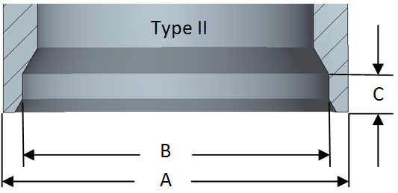

|  |  |  |  |
| --- | --- | --- | --- |
| **Dimensions** | **A** | **B** | **C** |
| **Throw 1, Suction** |  |  |  |
| **Throw 1, Discharge** |  |  |  |
| **Throw 2, Suction** |  |  |  |
| **Throw 2, Discharge** |  |  |  |
| **Throw 3, Suction** |  |  |  |
| **Throw 3, Discharge** |  |  |  |
| **Throw 4, Suction** |  |  |  |
| **Throw 4, Discharge** |  |  |  |
| **Throw 5, Suction** |  |  |  |
| **Throw 5, Discharge** |  |  |  |
| **Throw 6, Suction** |  |  |  |
| **Throw 6, Discharge** |  |  |  |